1) **Home Page :**

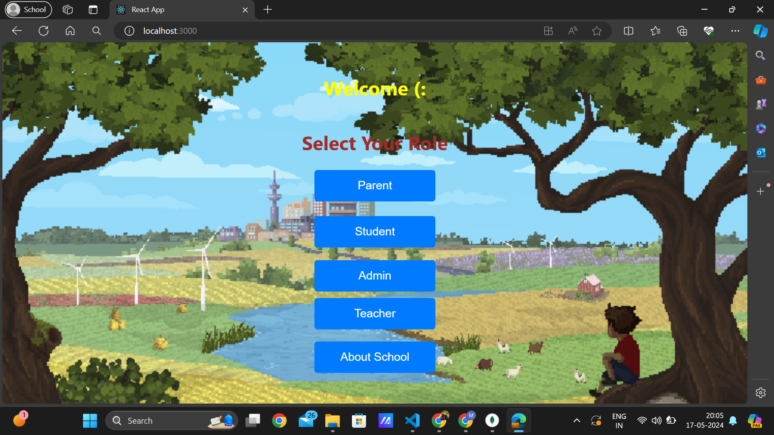

------------------------------------------------------------------------------------------------------------

1.1)**Parent Login :** -- {credentials for testing : UserName = test, Password = test}

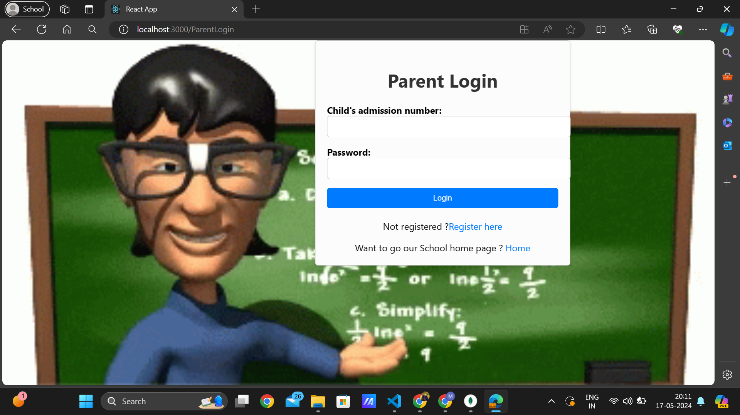

It only allows parent in after getting parent child (student) successfully enrolled in school database by Admin Assistant even though parent has done self registration.

-------------------------------------------------------------------------------------------------------------

1.2) **Parent Registration :**

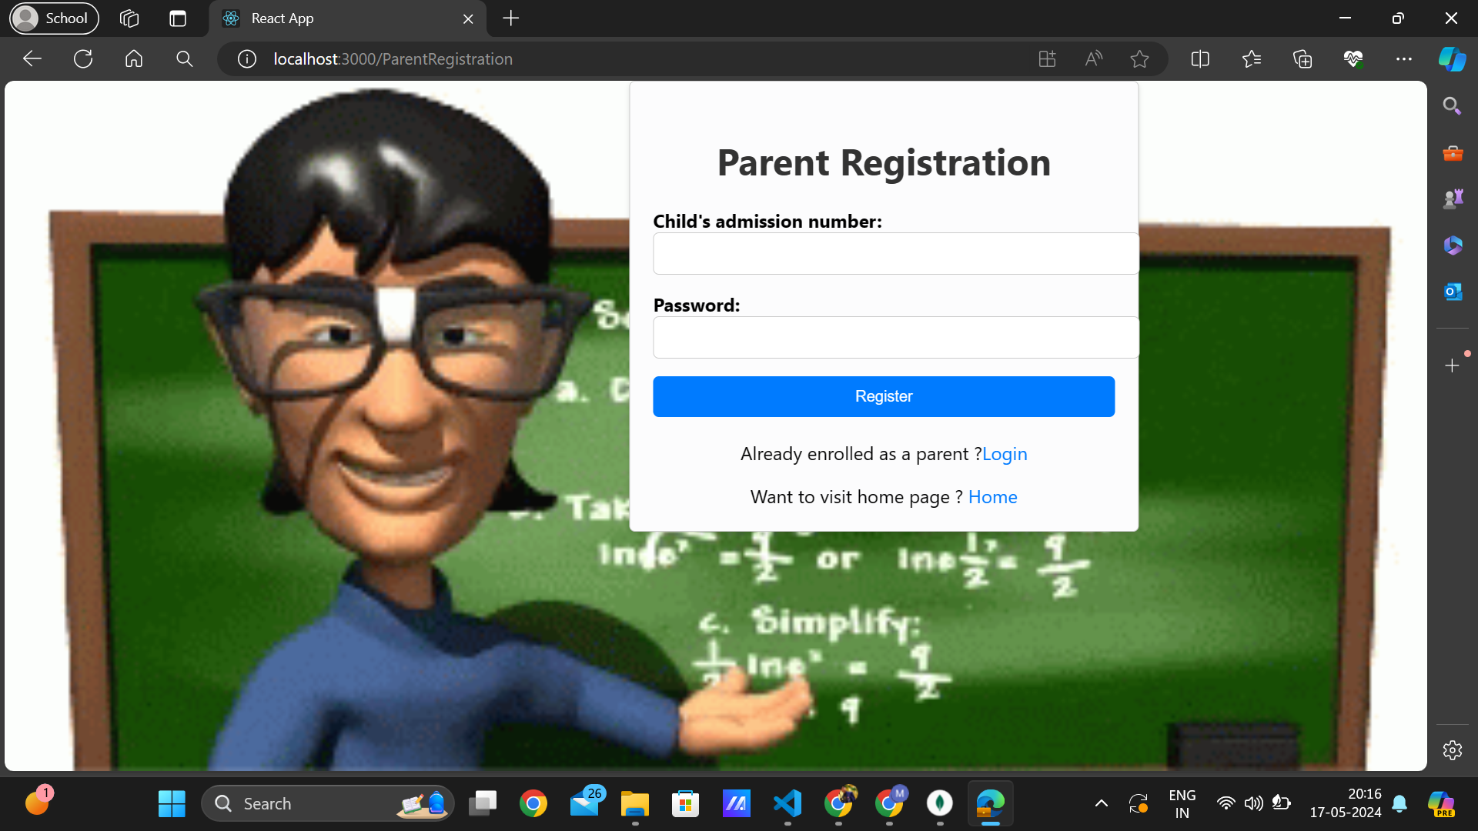

-------------------------------------------------------------------------------------------------------------

1.3) **Parent Dashboard :**

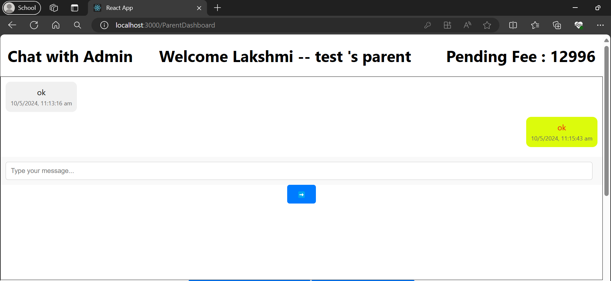

Parent can able to talk with school management (Admin Assistant) anytime through this chatting feature. Its a real time continuous synchronous application.

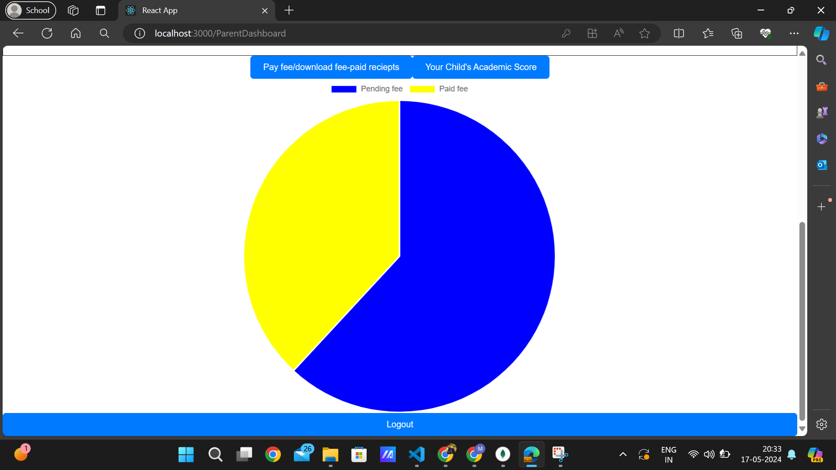This is a pie chat showing pending fee in blue and paid fee in yellow.

-------------------------------------------------------------------------------------------------------------

1.4) **Paying fee and dowloading fee receipts feature of parent :**

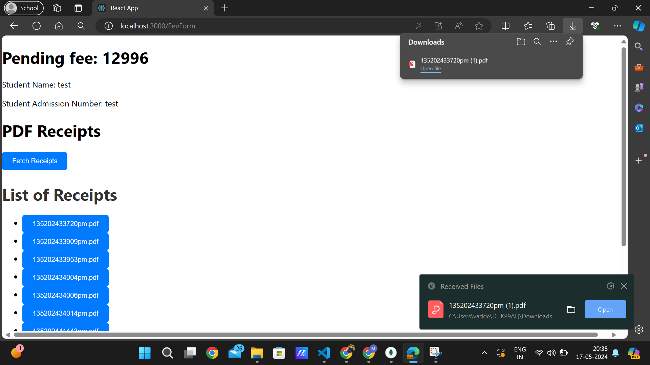

Parent can able to download the fee recieptsafter clicking on fetch reciepts and clicking on the particular receipt.

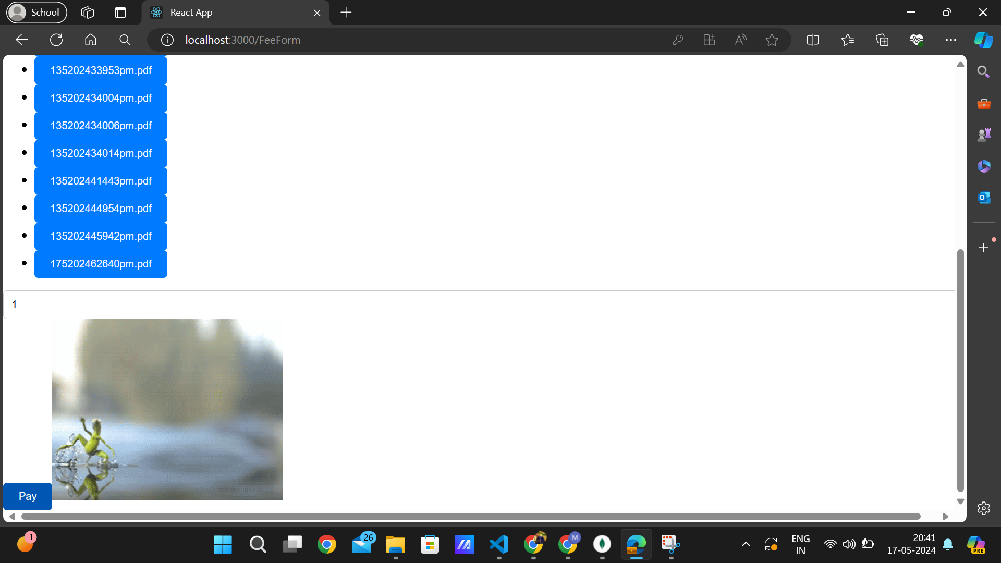

This is the page to download fee paid reciepts and to pay the fee and while paying the fee, it will display a gif as shown above and after successfull transaction, it wont appear.

**Fee Receipt :**

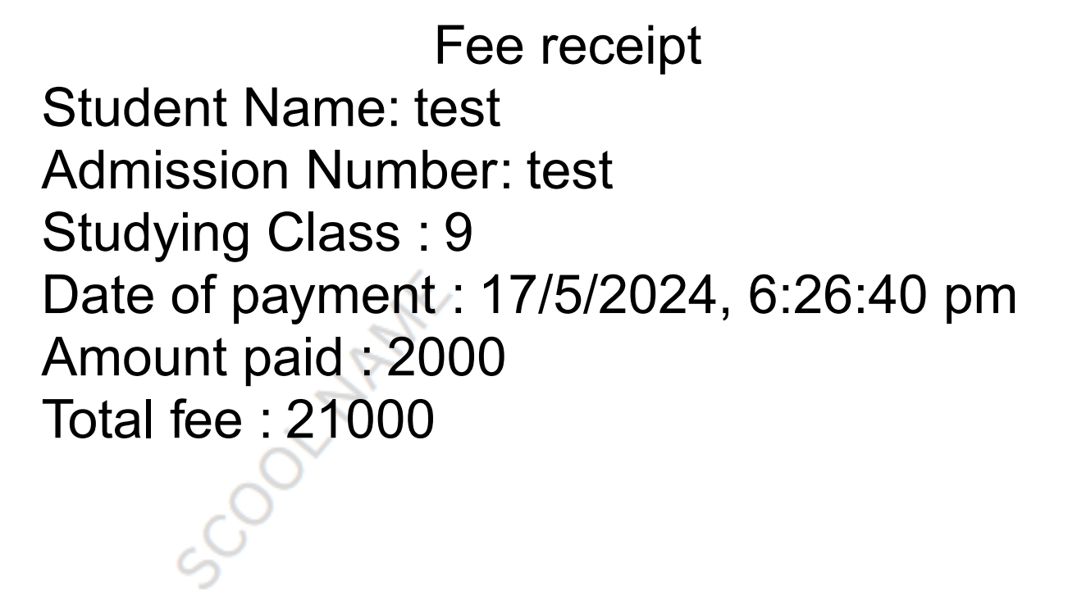

-------------------------------------------------------------------------------------------------------------

1.5) **Displaying Child academic score in the parent login :**

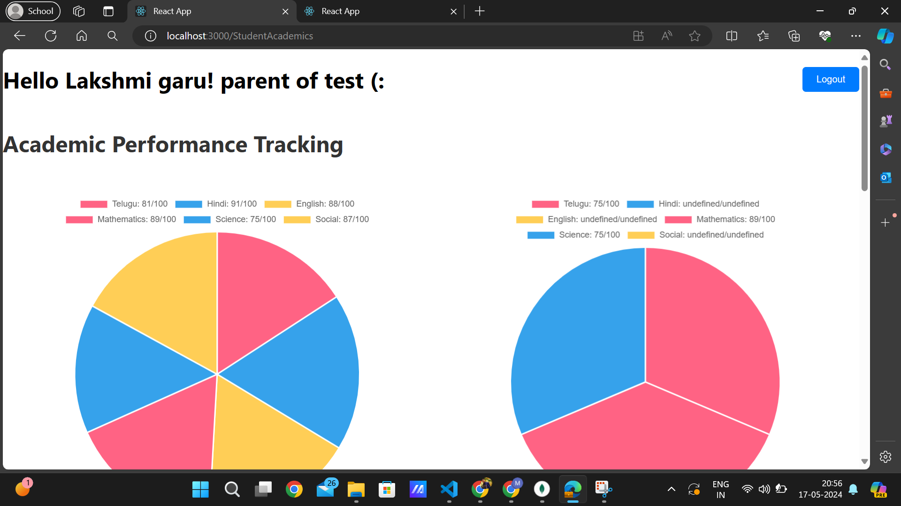

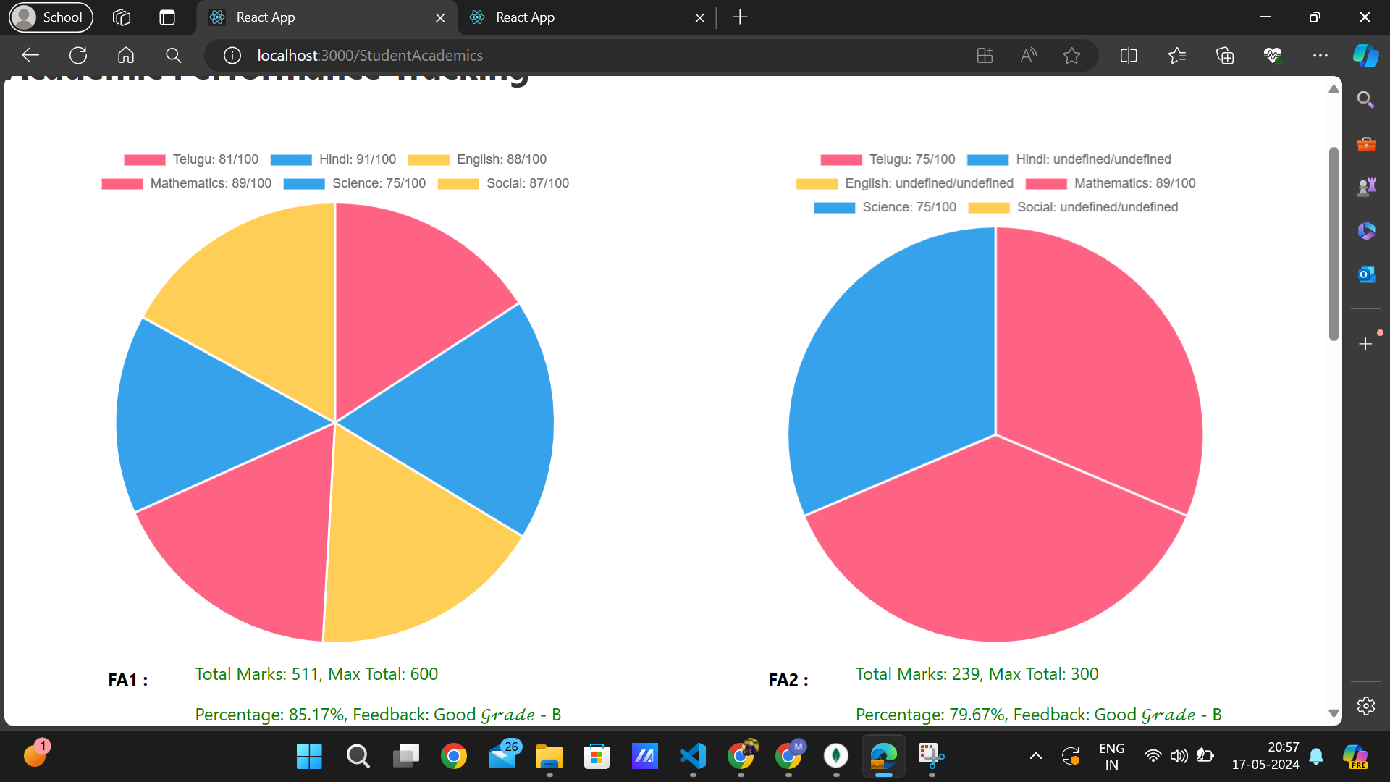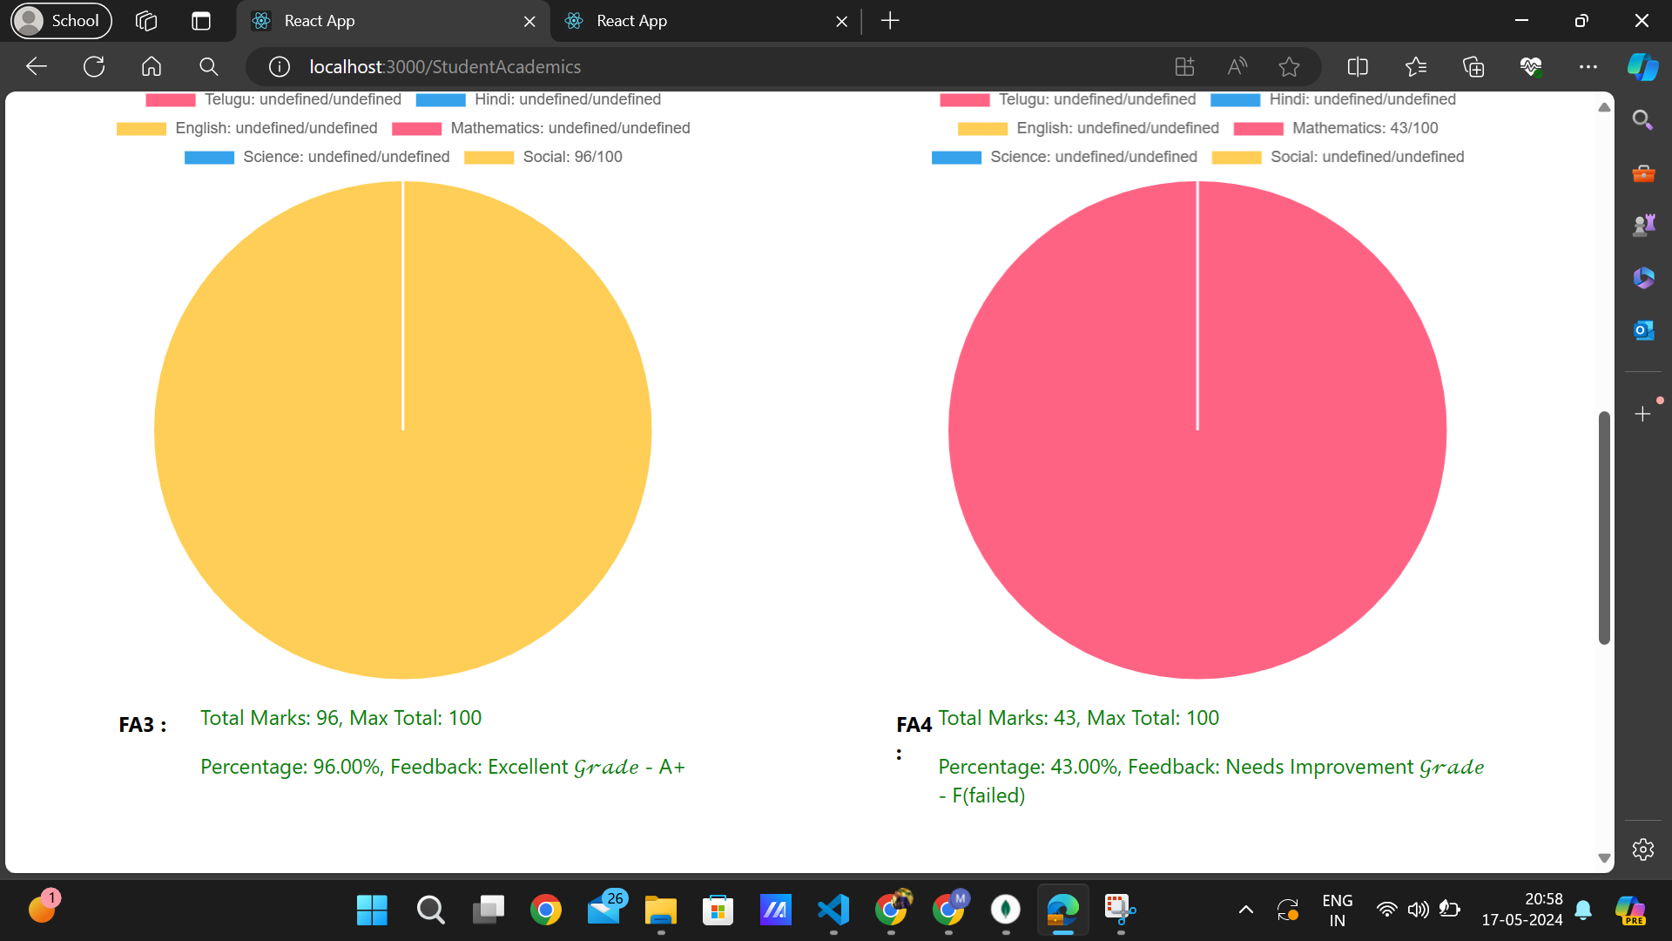

Totally, there are exam types : fa1, fa2, fa3, fa4.

It automatically calculates the percentage and feedback of the academic score of the student whenever the respective teacher has alloted the marks.

After alloting all the subjects i.e., telugu, hindi, english, mathematics, science, social of all exam Types, It automatically calculates displays a button of “promote to next class” if student has passed all the subjects i.e., >50 in each subject.

And whenever student clicks the “promote to next class” button, his details would automatically updates in the school database, but failed student details would still stays in the same class.

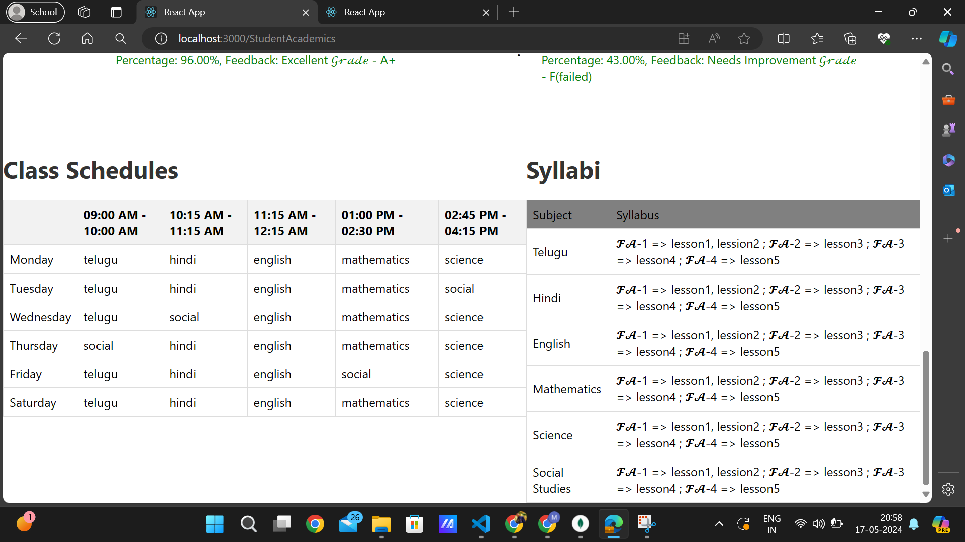

This is the Syllabus and time table of the student (Child of the respective parent). These could be added by the Admin Assistant with the suggetions of respective class teachers.

-------------------------------------------------------------------------------------------------------------

2.1)**Student Login :** {credentials for testing : UserName = test, Password = test}

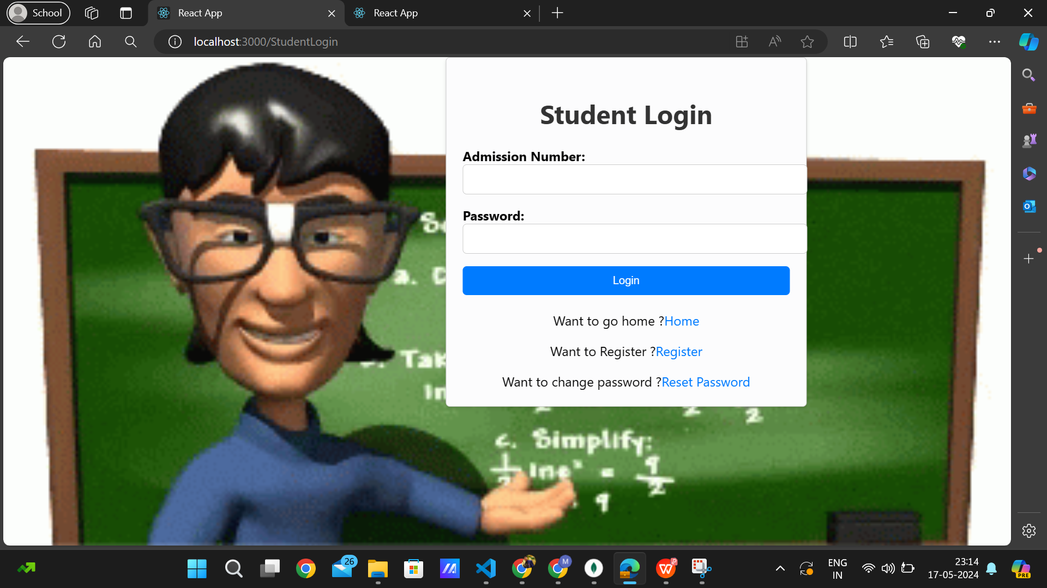

It only allows student in after getting student successfully enrolled in school database by Admin Assistant even though student has done self registration.

-------------------------------------------------------------------------------------------------------------

2.2)**Student Registration :**

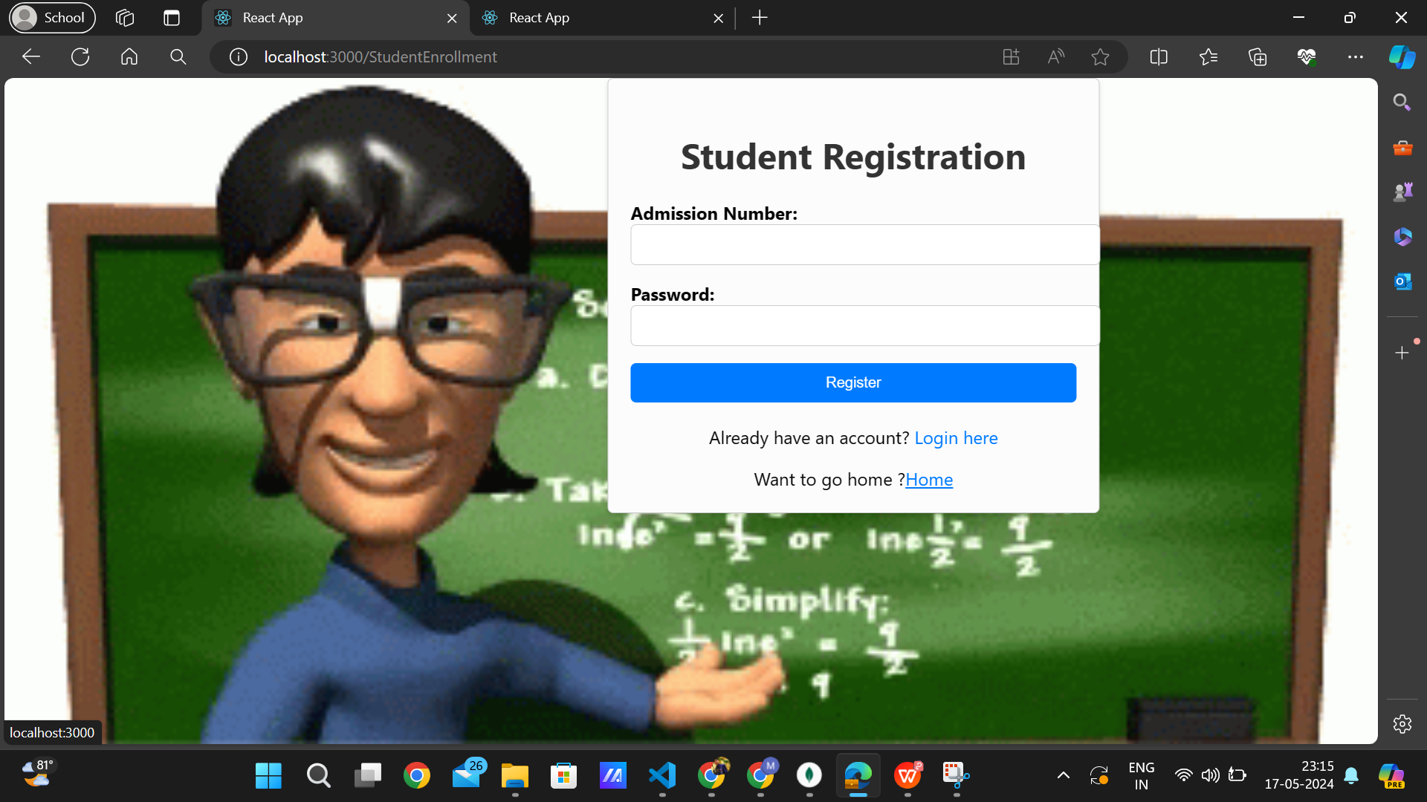

-------------------------------------------------------------------------------------------------------------

2.3)**Student Dashboard :**

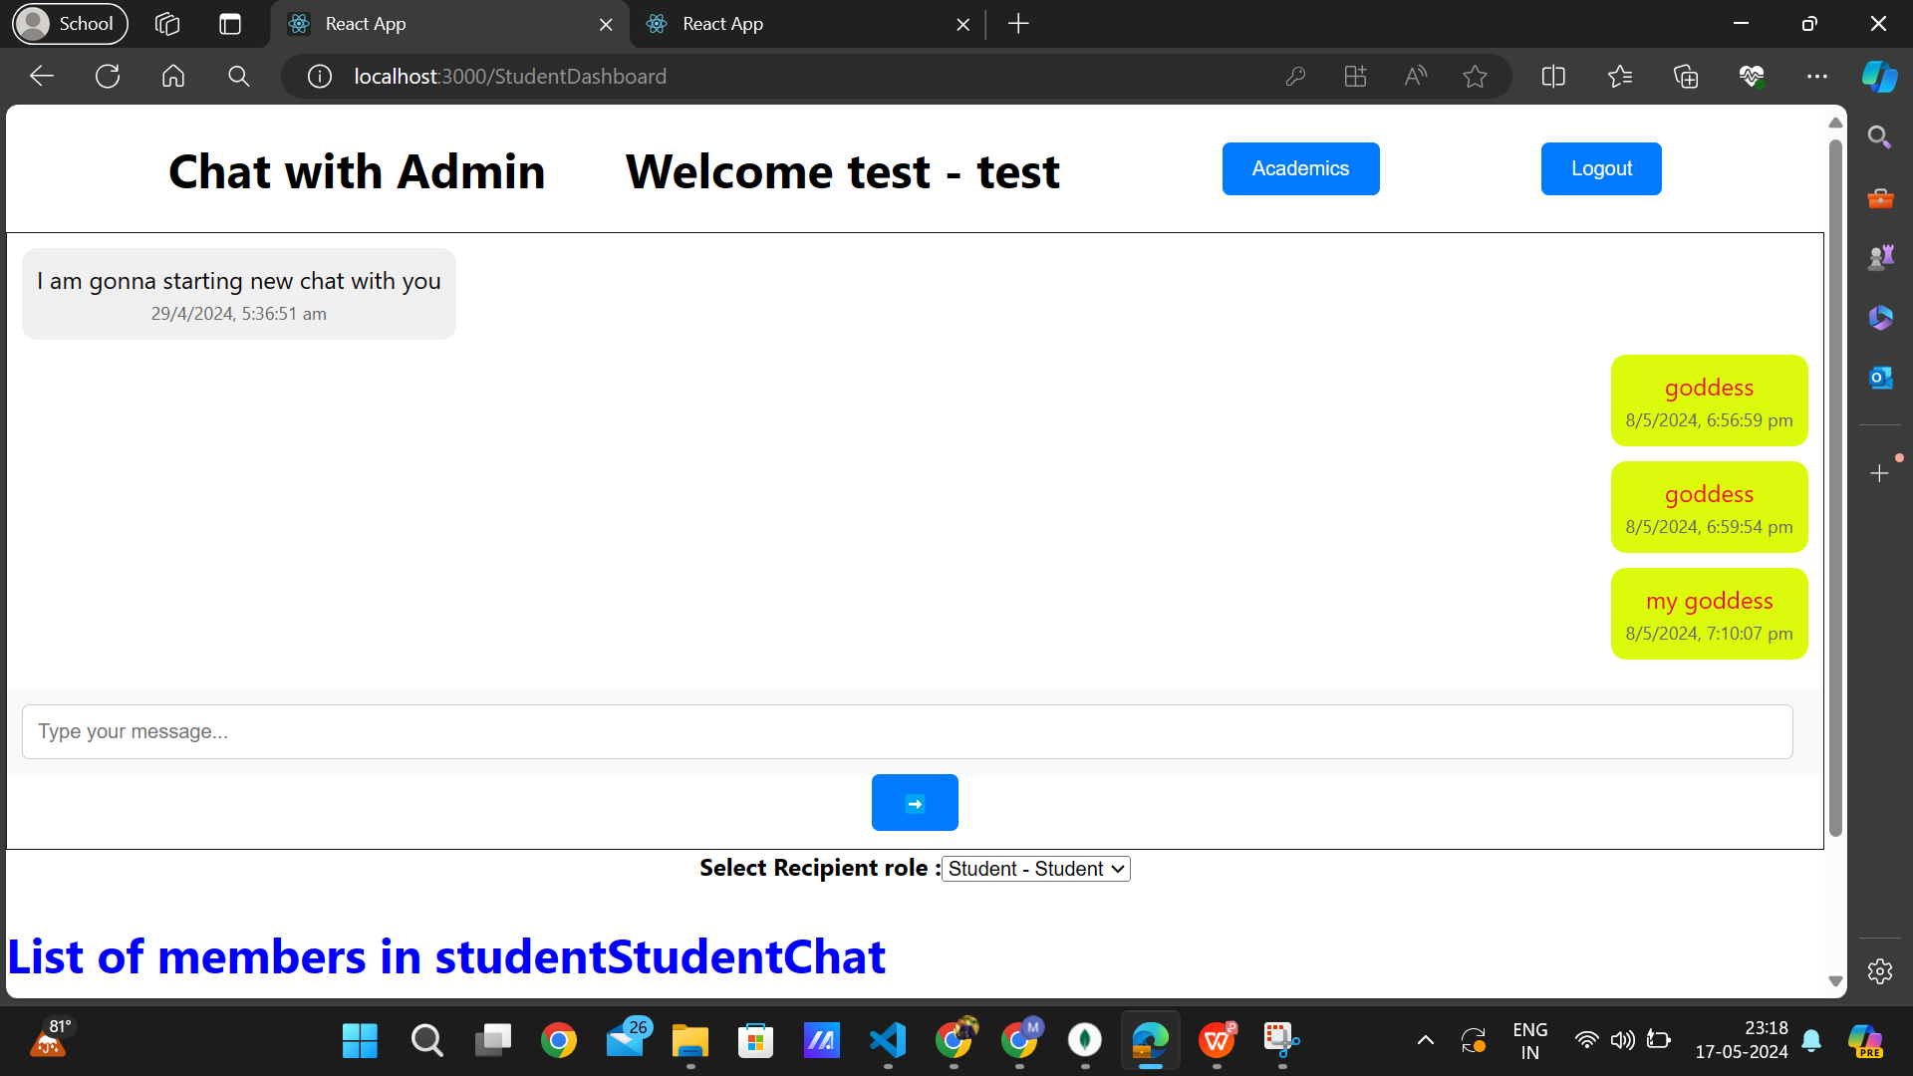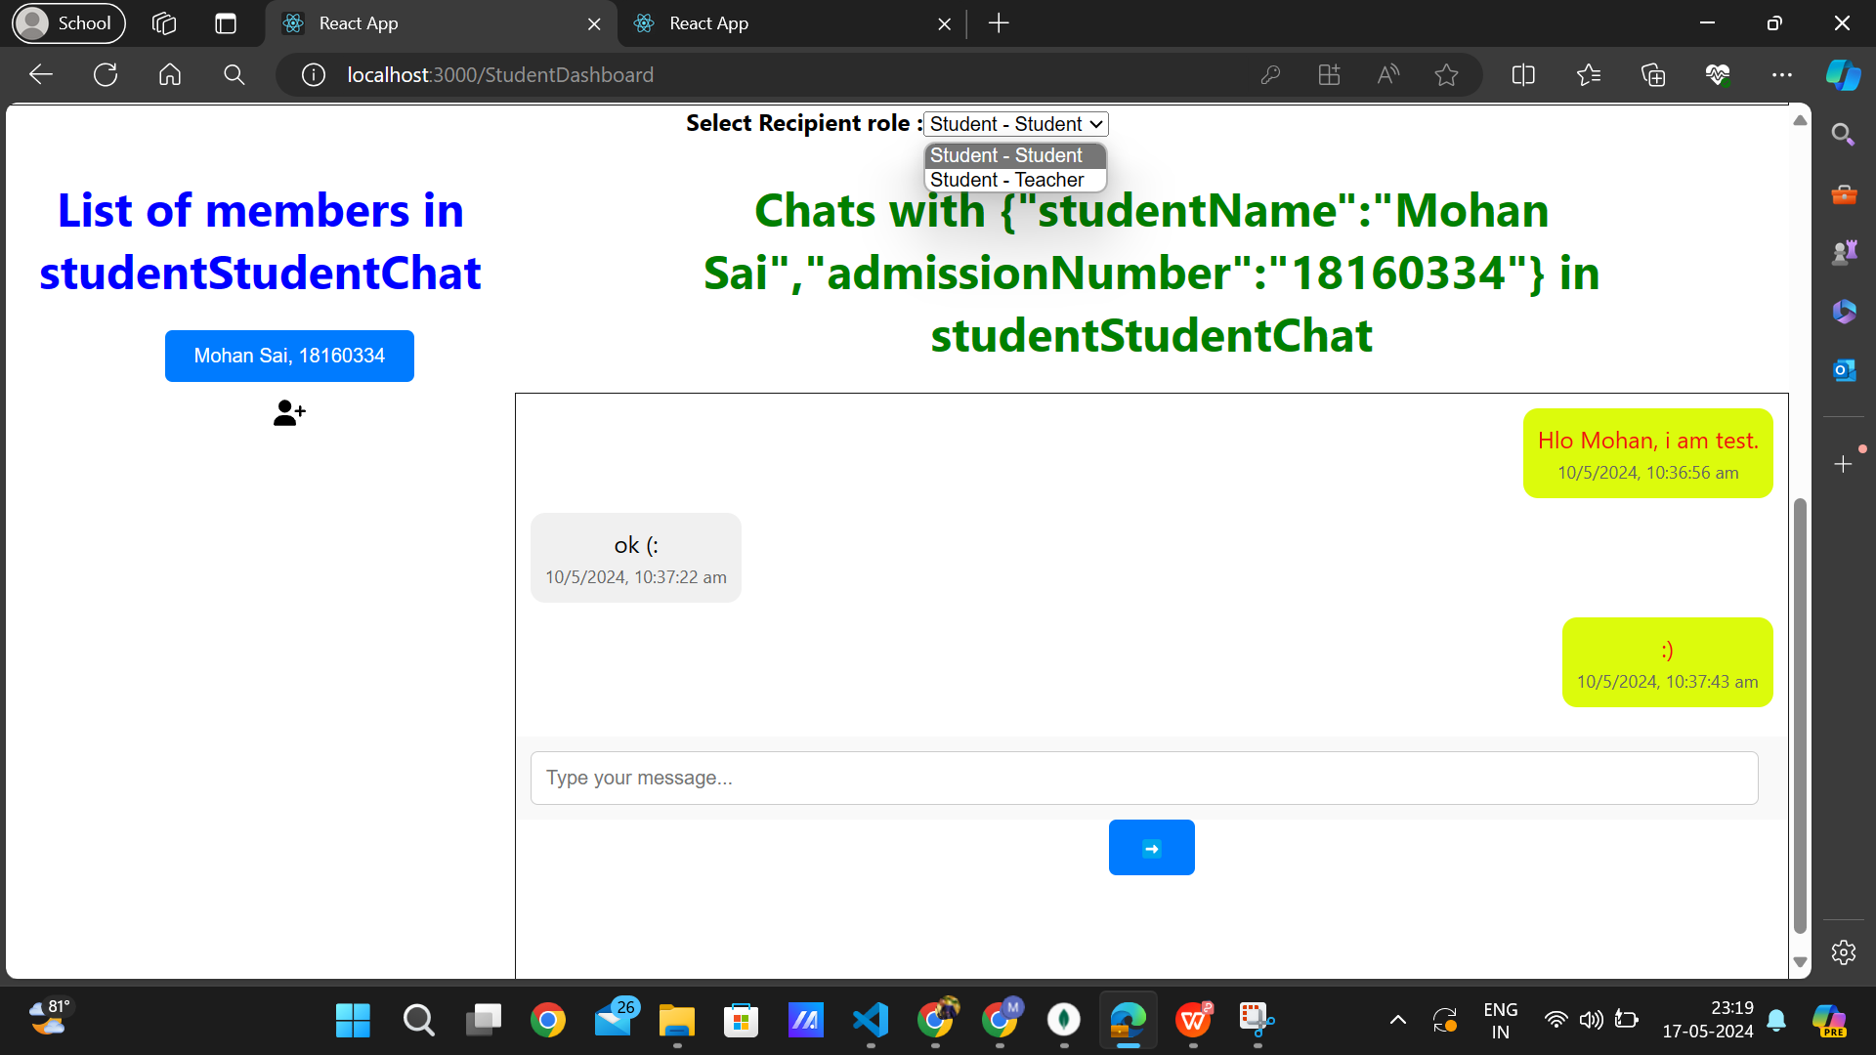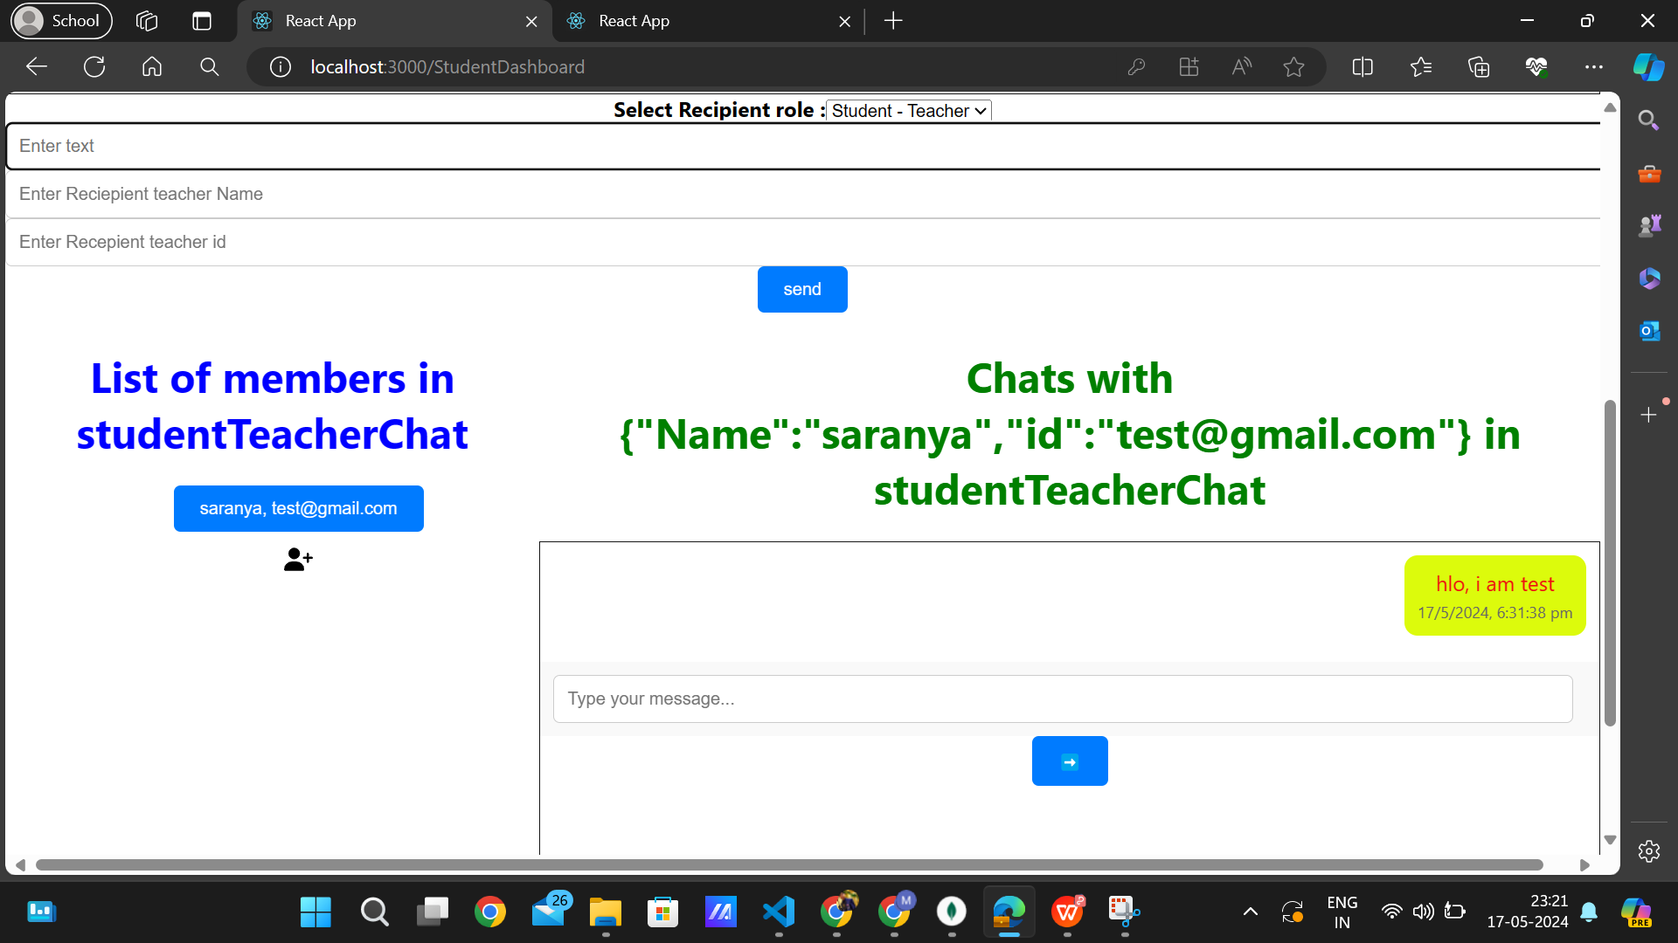

To Chat with a new teacher or new student, one should click on the add symbol and should give corresponding details for a new chat as shown above.

-------------------------------------------------------------------------------------------------------------

2.4) Student Academics :

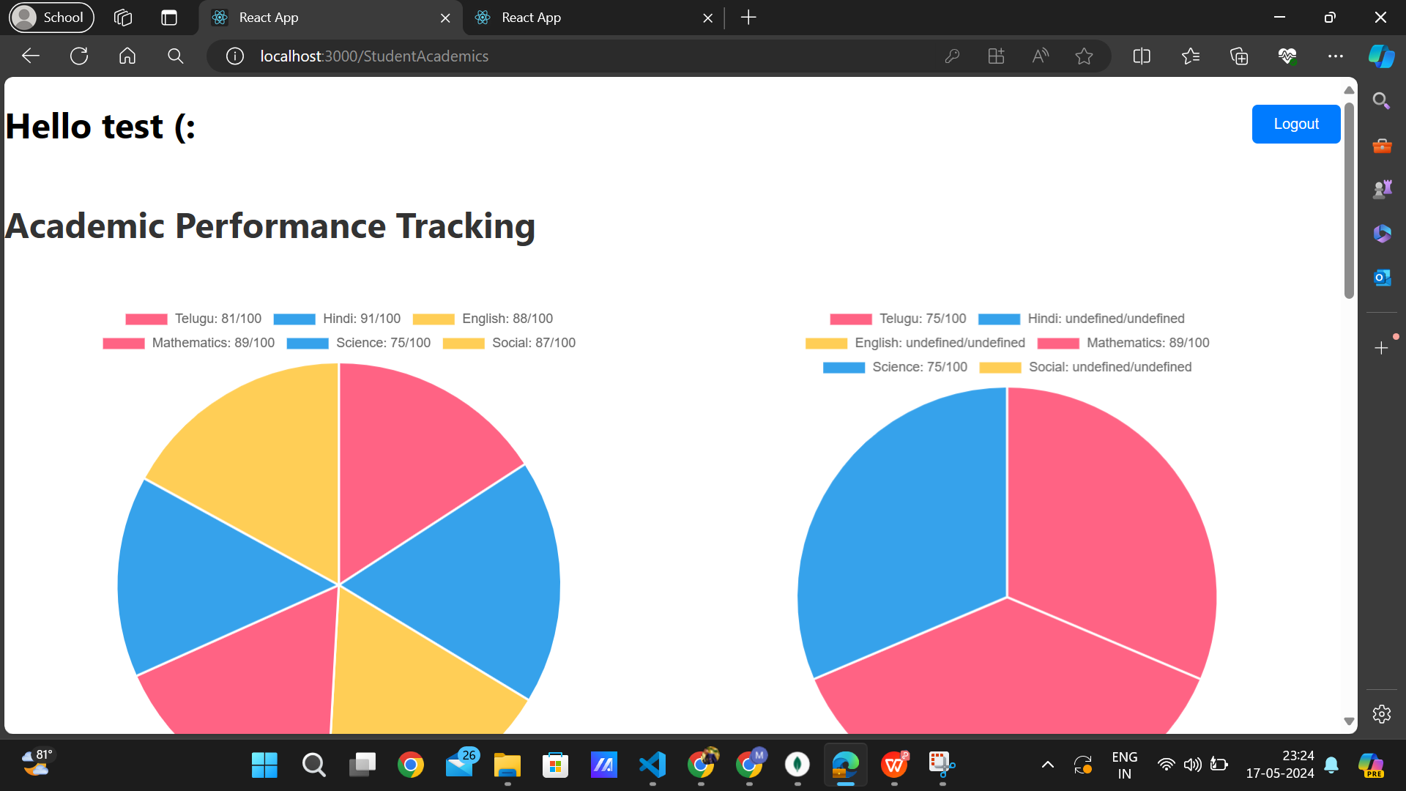



Totally, there are exam types : fa1, fa2, fa3, fa4.

It automatically calculates the percentage and feedback of the academic score of the student whenever the respective teacher has alloted the marks.

After alloting all the subjects i.e., telugu, hindi, english, mathematics, science, social of all exam Types, It automatically calculates displays a button of “promote to next class” if student has passed all the subjects i.e., >50 in each subject.

And whenever student clicks the “promote to next class” button, his details would automatically updates in the school database, but failed student details would still stays in the same class.



This is the Syllabus and time table of the student . These could be added by the Admin Assistant with the suggetions of corresponding class teachers.

-------------------------------------------------------------------------------------------------------------

3.1) **AdminLogin** : -- {credentials for testing : UserName = test, Password = test}

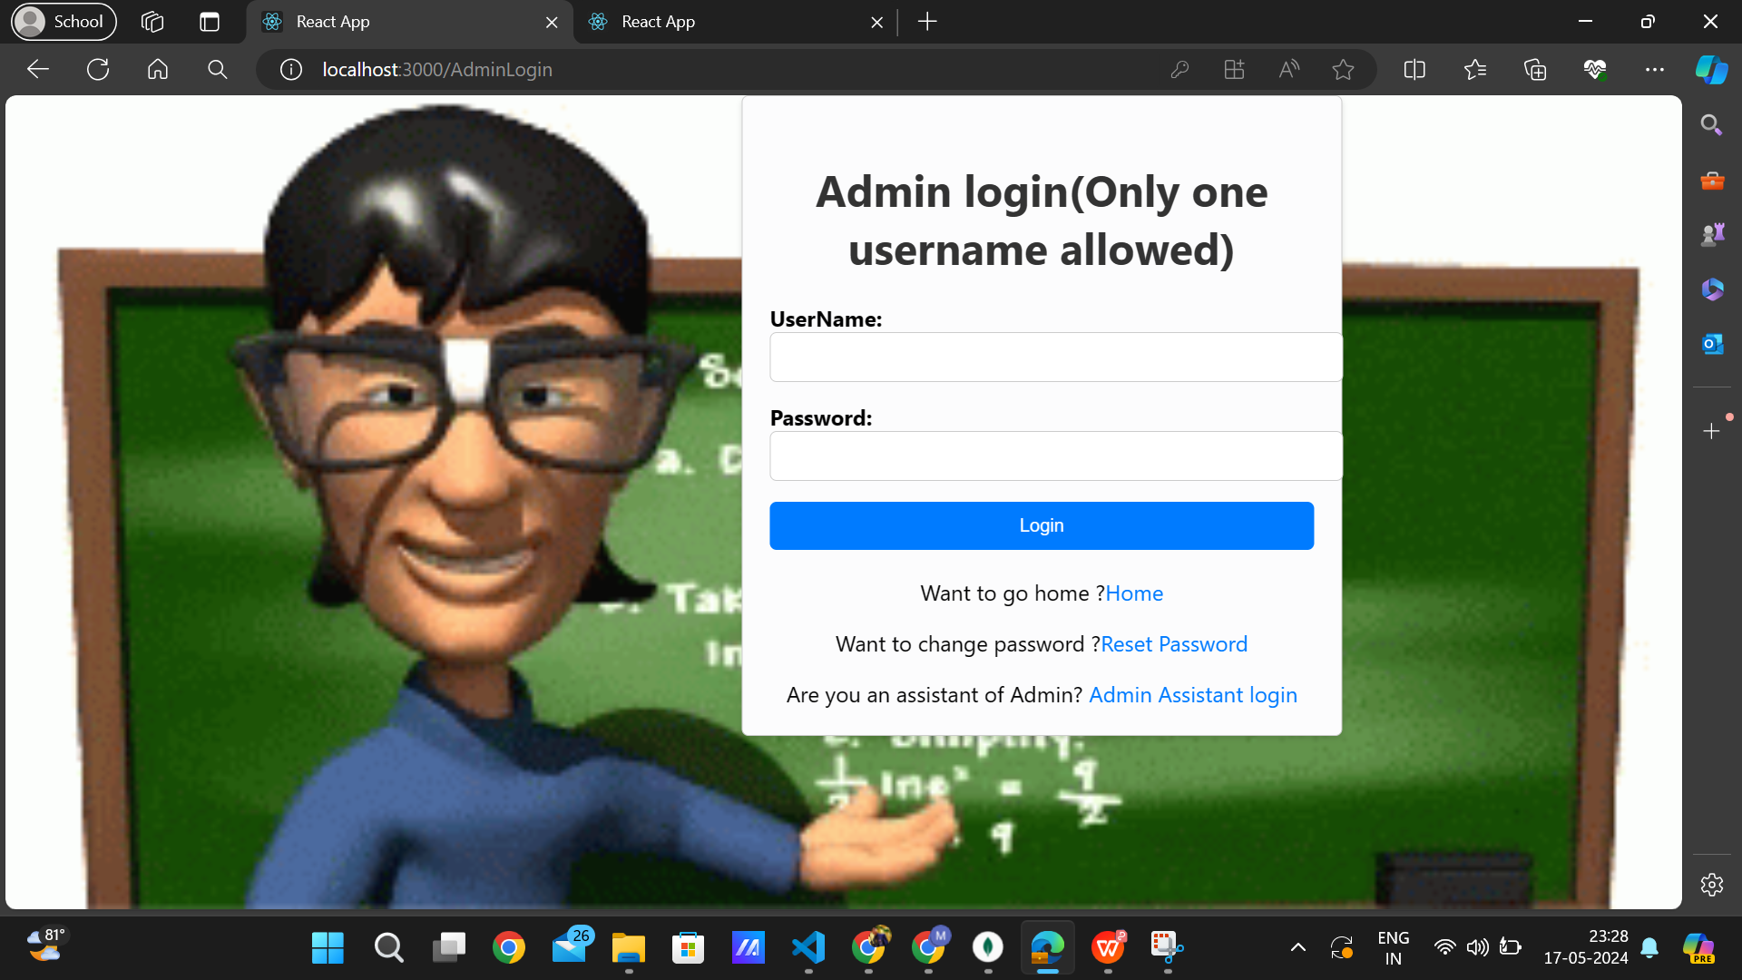

-------------------------------------------------------------------------------------------------------------

3.2) **Admin Dashboard :**

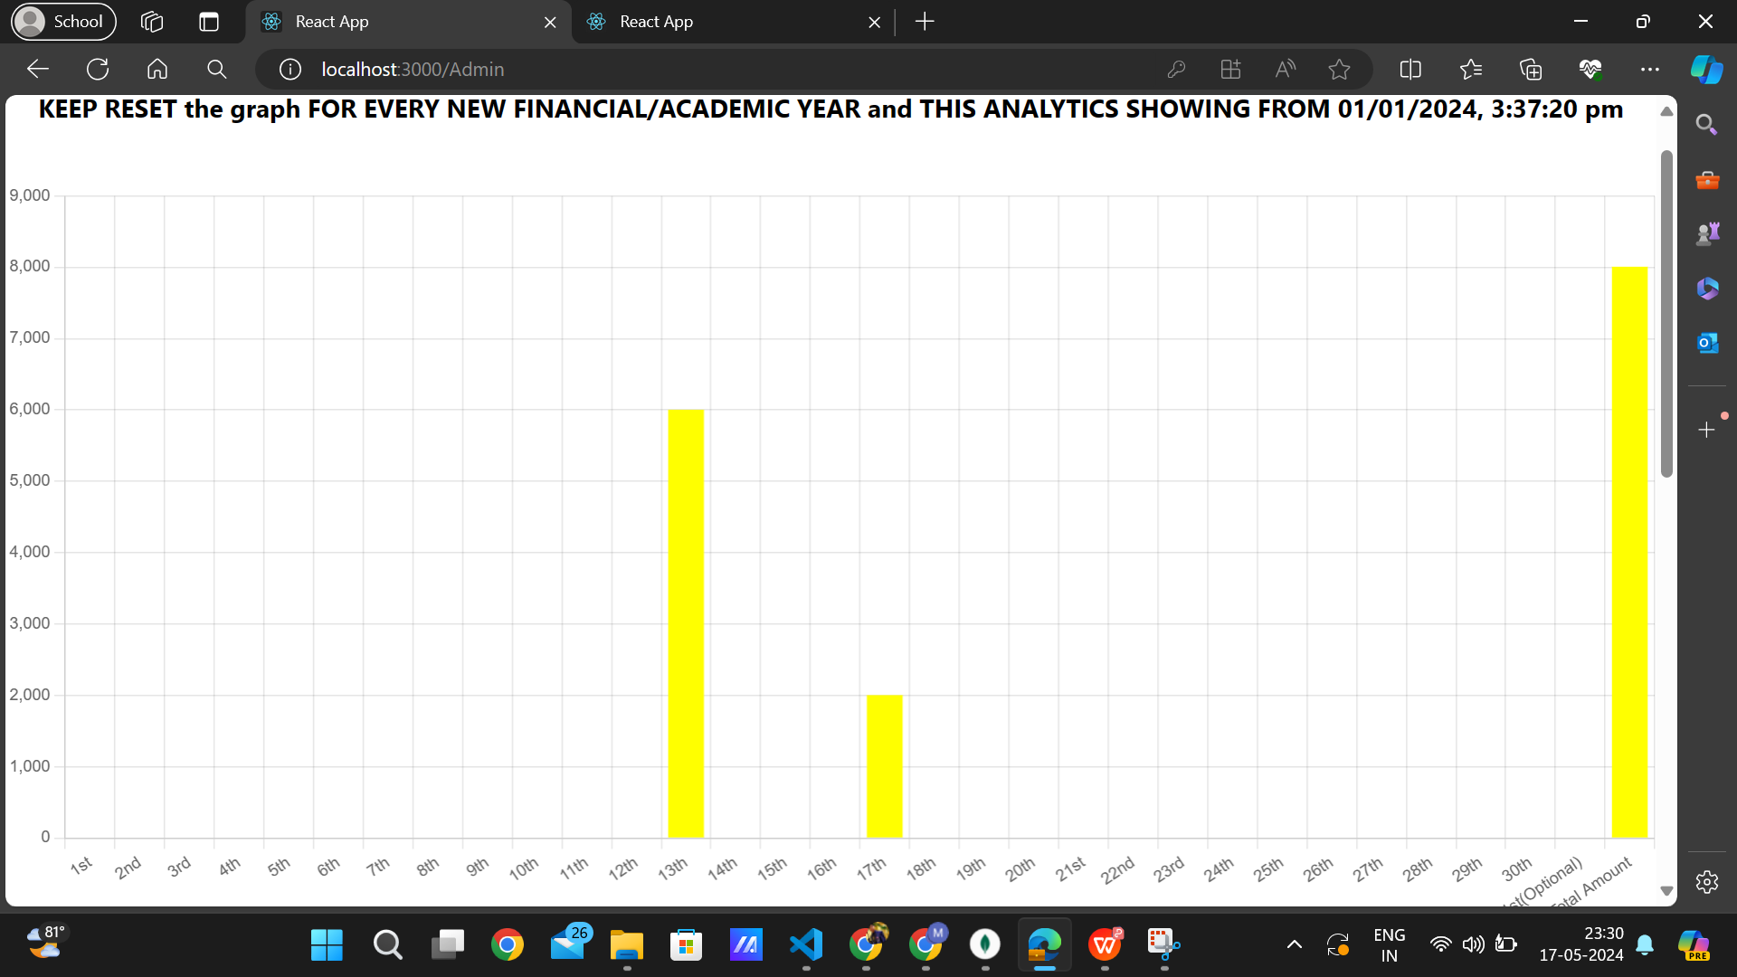

This graph shows the overall analytics of fee collection daywise in each month.

By default it displays the present month’s statistics.

And fee analytics display from the date of 01/01/2024 as show in the above figure. However you can reset this anytime later..

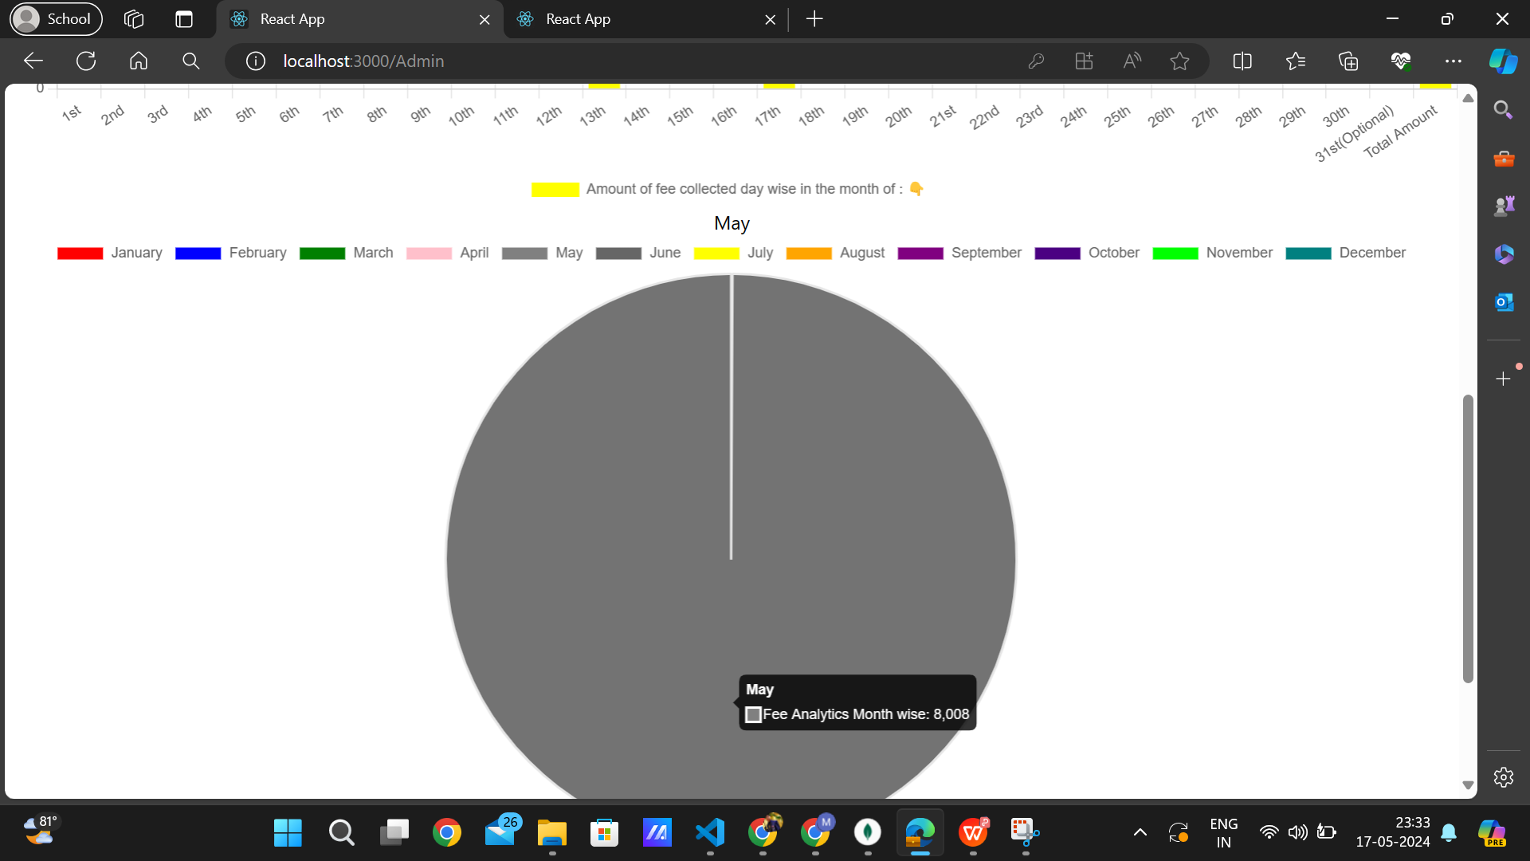

Since there is no fee colected in the month other than may, its not displaying any other month and only displays the month in which fee collection has done. And whenever clicks on the particular month on the pie chat, it displays the day wise fee collection analytics in the bar graph as shown previously.

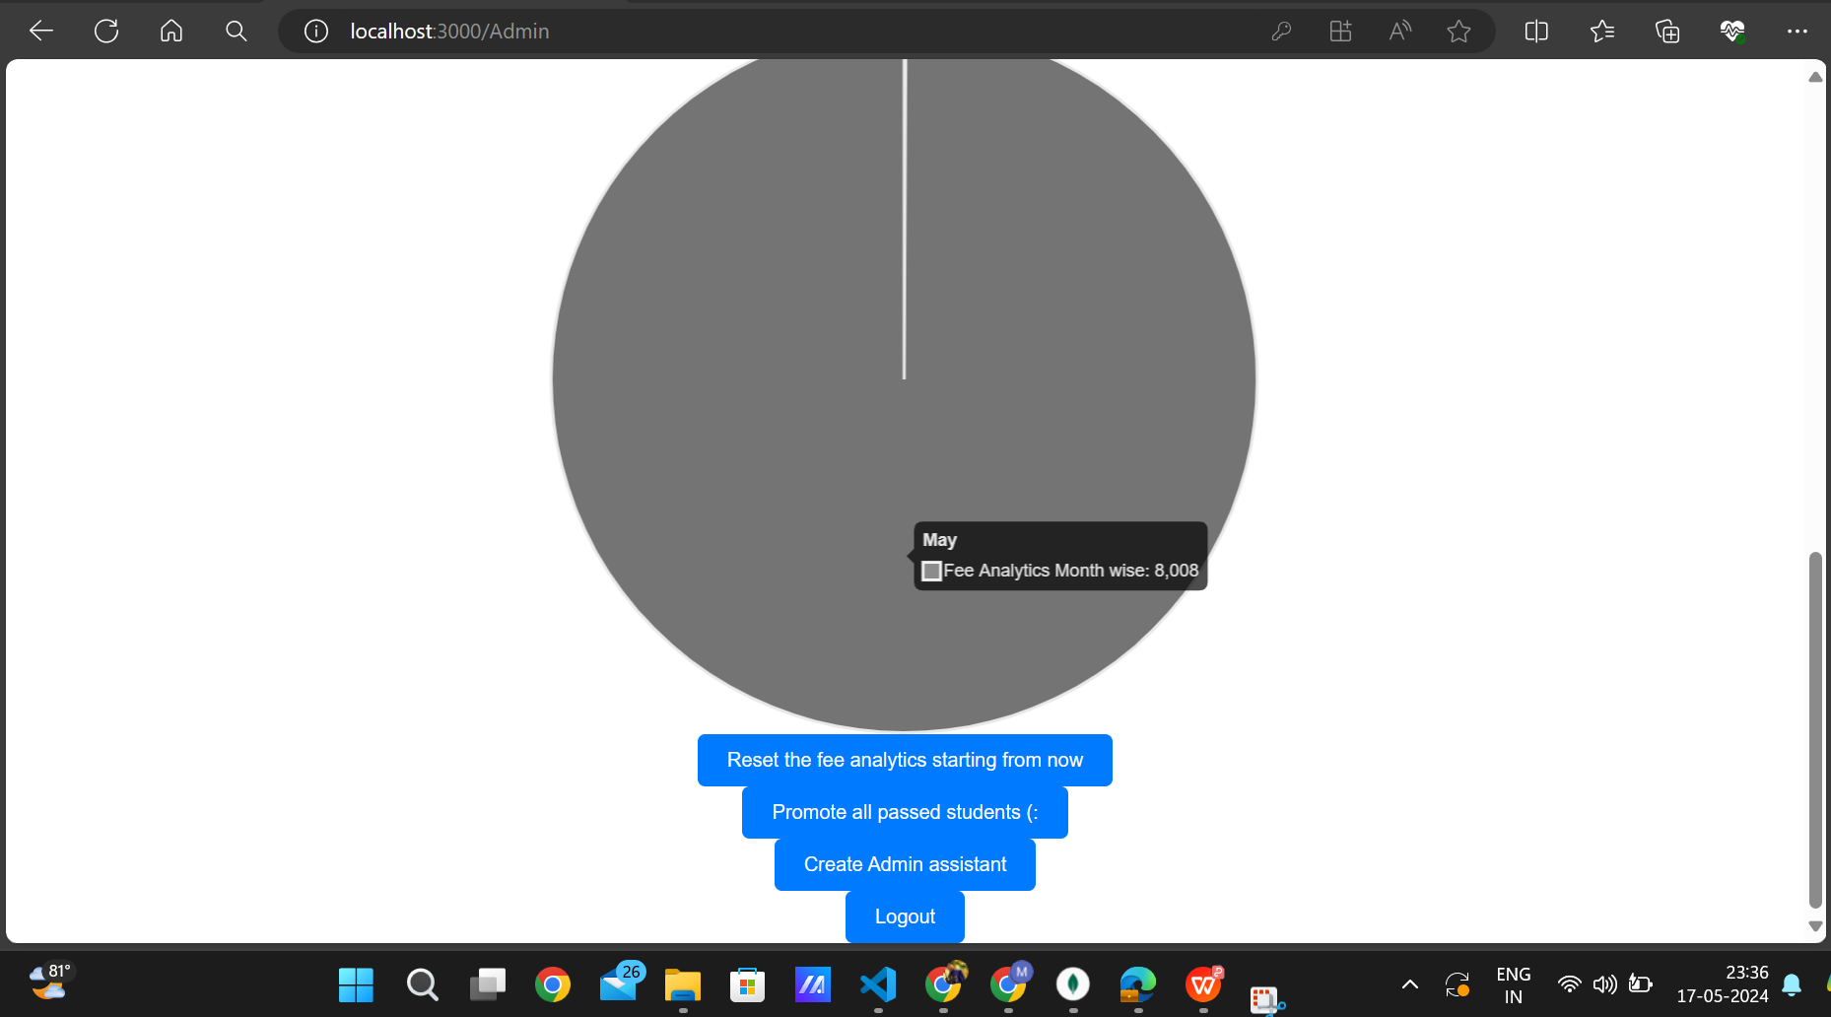

“Reset the fee analytics starting from now” button sets the fee analytics statistics from the current date.

“Promote all passed students” button will update the student’s academic year in fee details automatically by just clicking on it”

“create admin assist” button will register the admin assistant.

-------------------------------------------------------------------------------------------------------------

3.3)Admin Assist Registration By admin(only) :

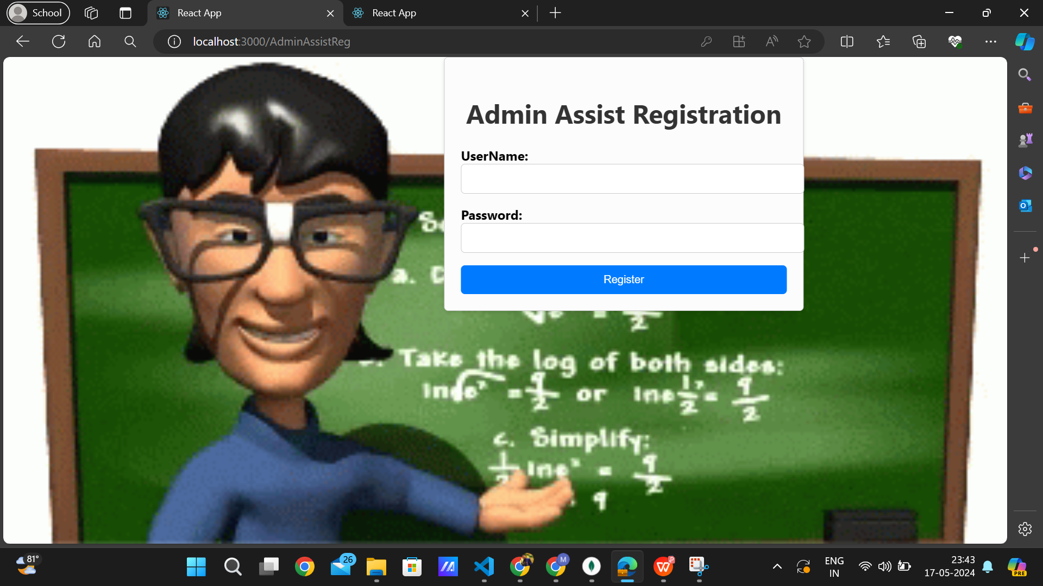

-------------------------------------------------------------------------------------------------------------

3.4) **Admin Assistant Login :** {credentials for testing : UserName=test, Password=test}

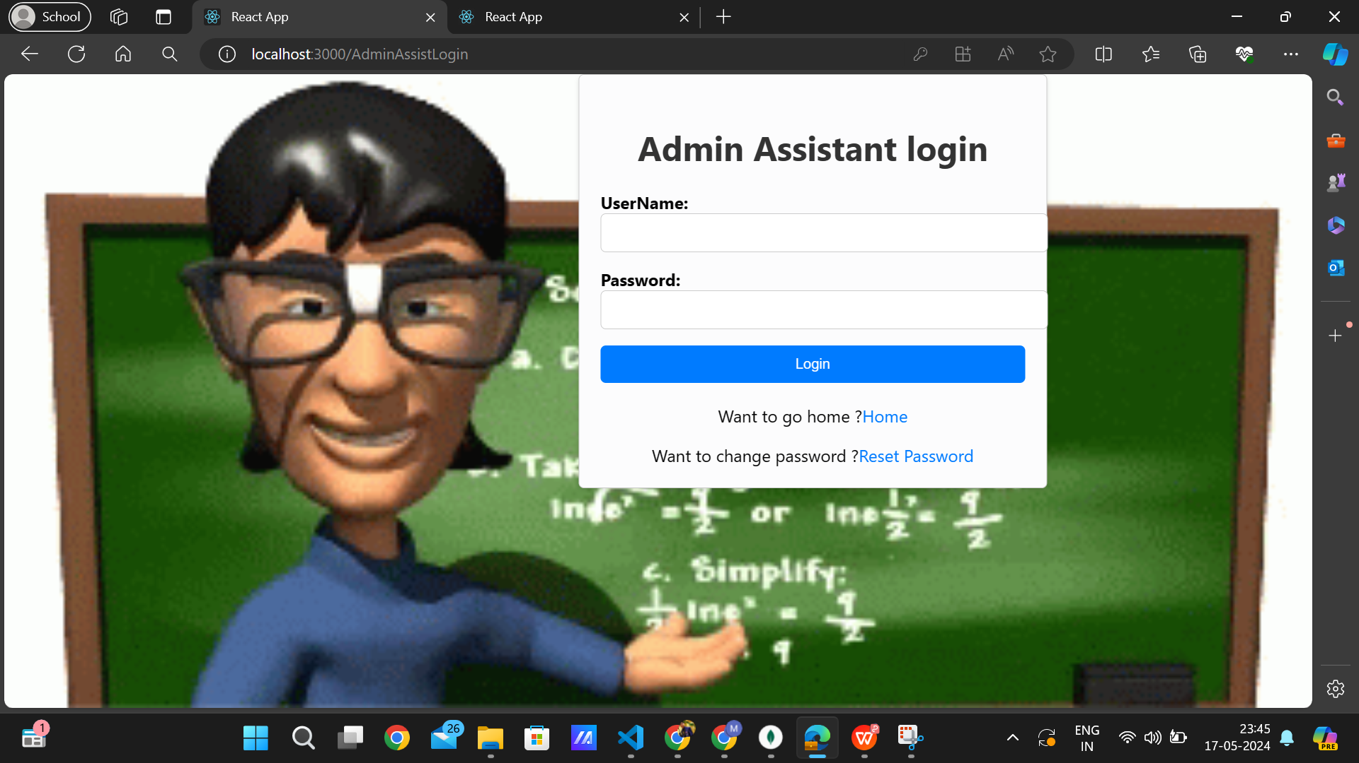

-------------------------------------------------------------------------------------------------------------

3.5)**Admin Assistant Dashboard :**

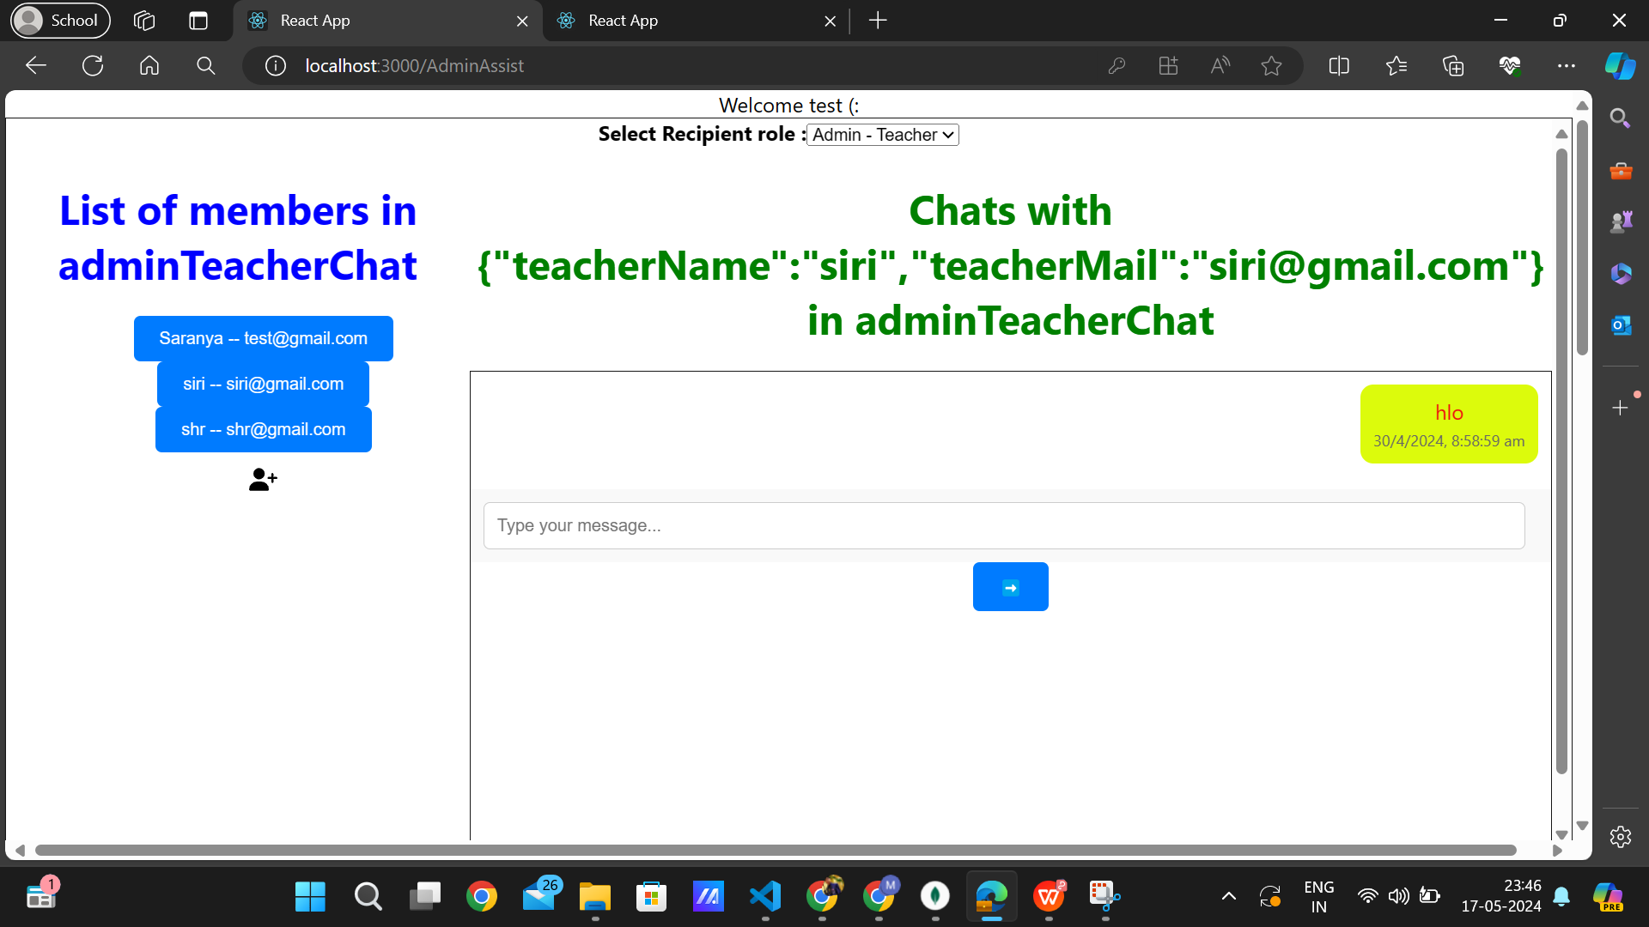

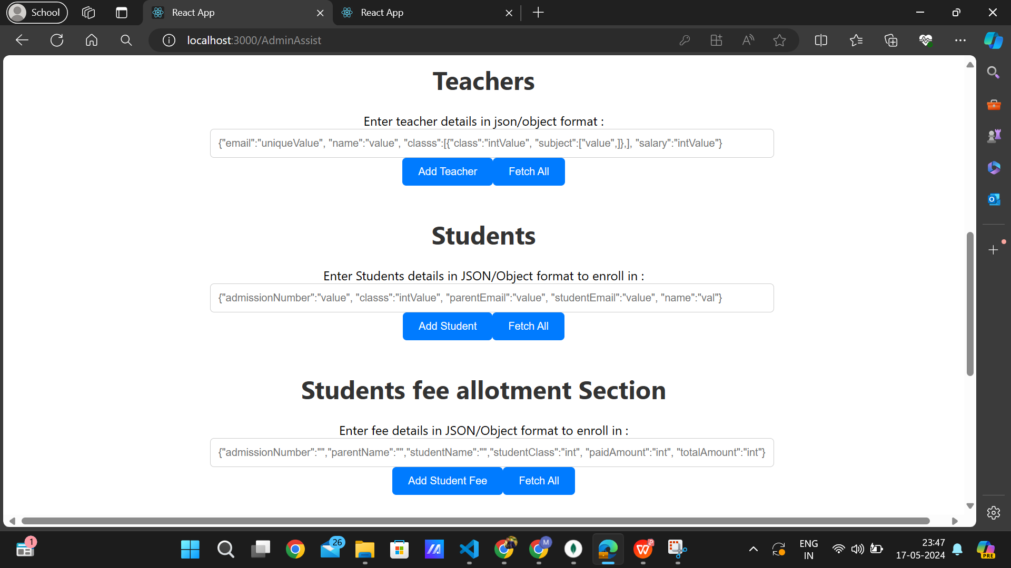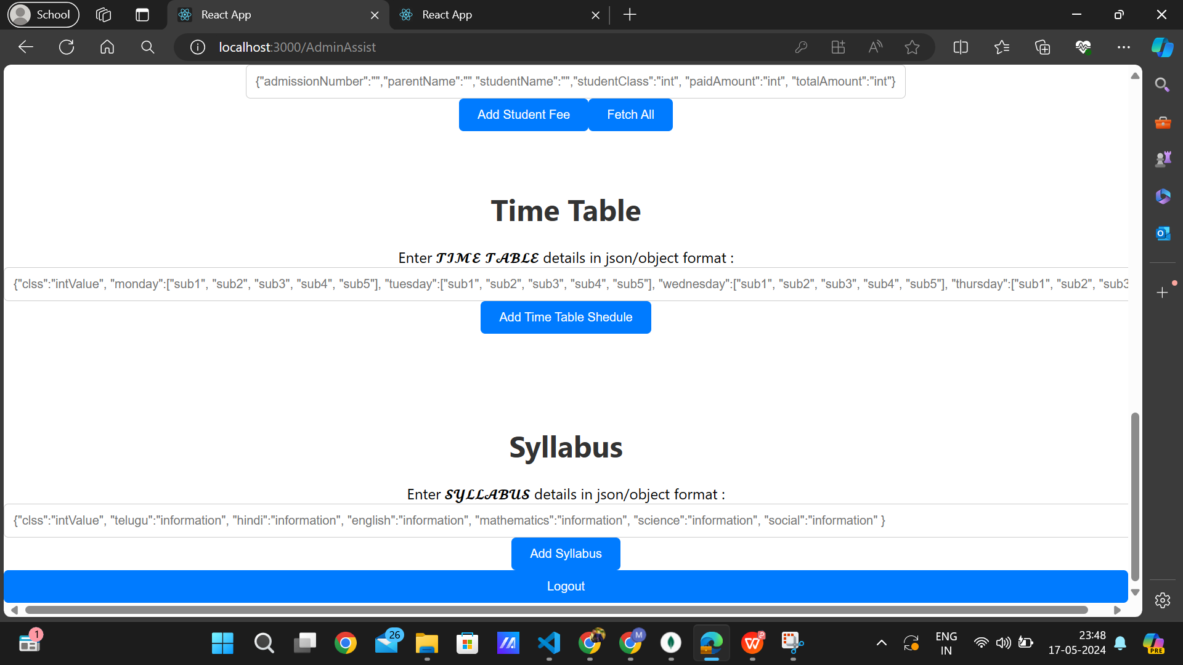

All details should be entered by an admin in json format to enroll in school database. Also admin assistant can able to edit the information by fetching then and clicking edit button delete button as shown bellow for each role :

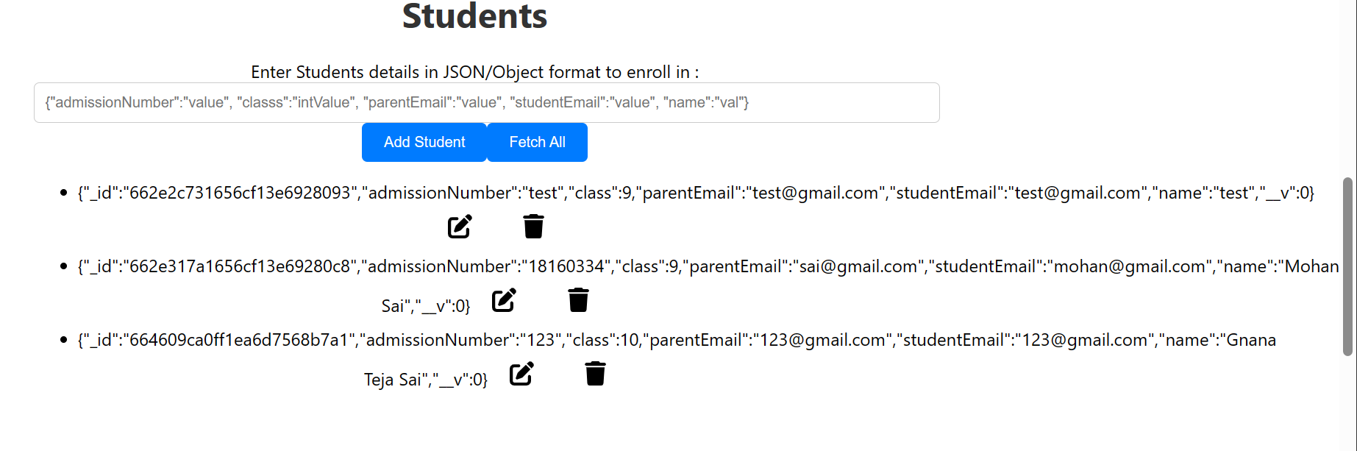

-------------------------------------------------------------------------------------------------------------

4.1) **Teacher Login :** {credentials for testing : UserName=test@gmail.com, Password=test}

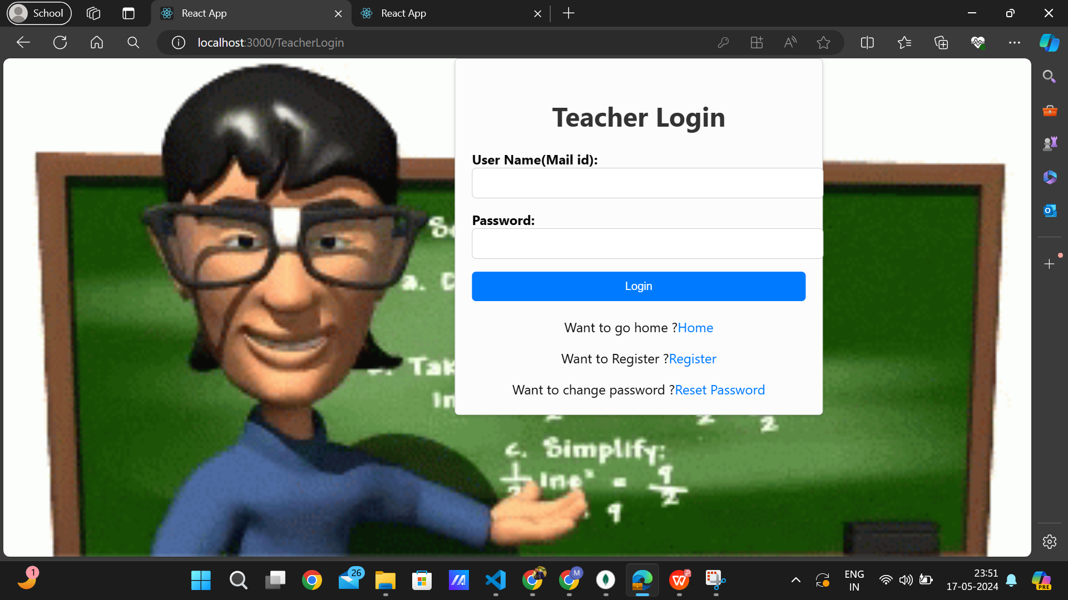

It only allows teacher in after getting student successfully enrolled in school database by Admin Assistant even though teacher has done self registration.

------------------------------------------------------------------------------------------------------------

4.2) **Teacher Registration :**

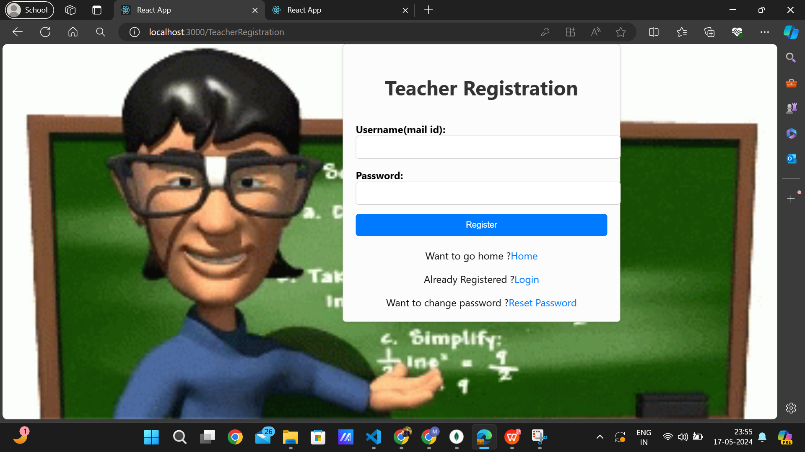

-------------------------------------------------------------------------------------------------------------

4.3) **Teacher Dashboard :**

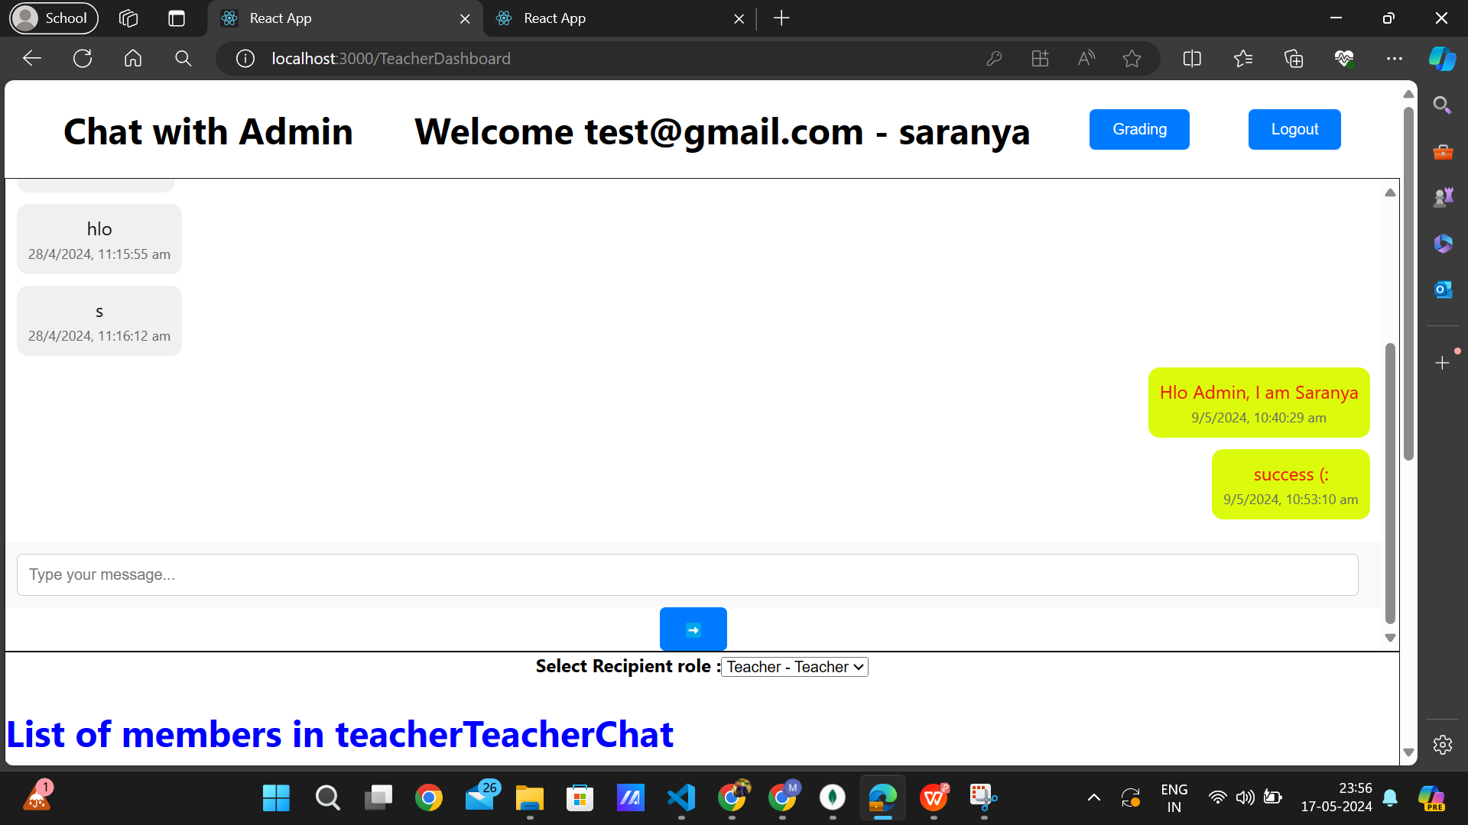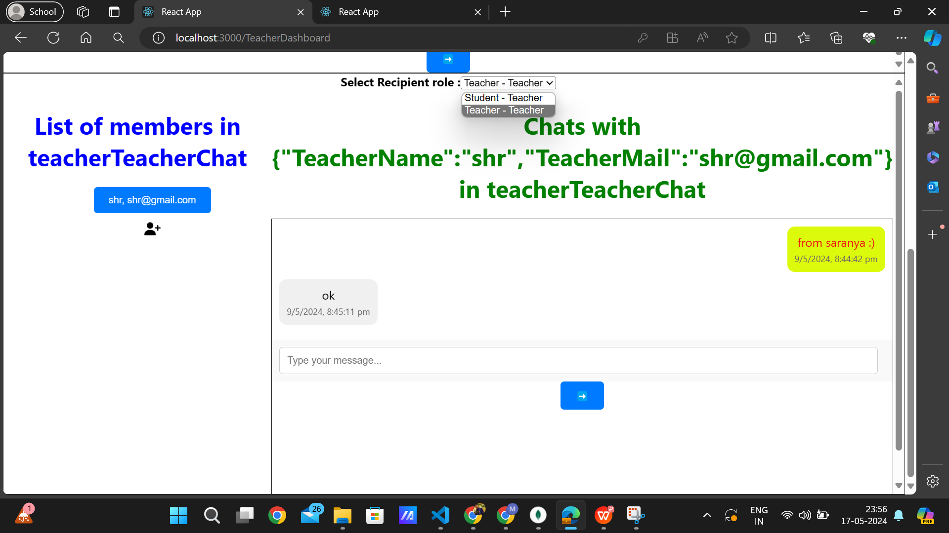

-------------------------------------------------------------------------------------------------------------

4.4)**Marks allocation by a teacher for her respective classes’s subject’s students :**

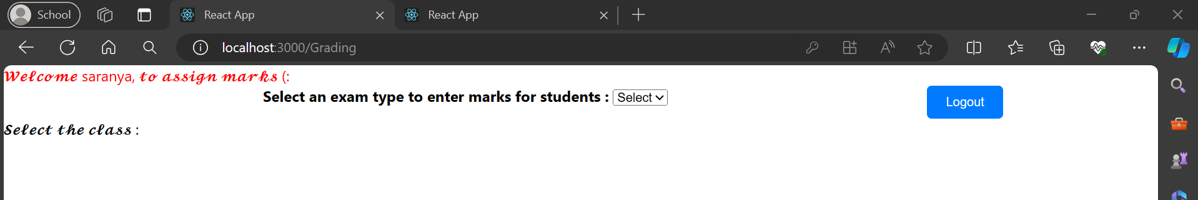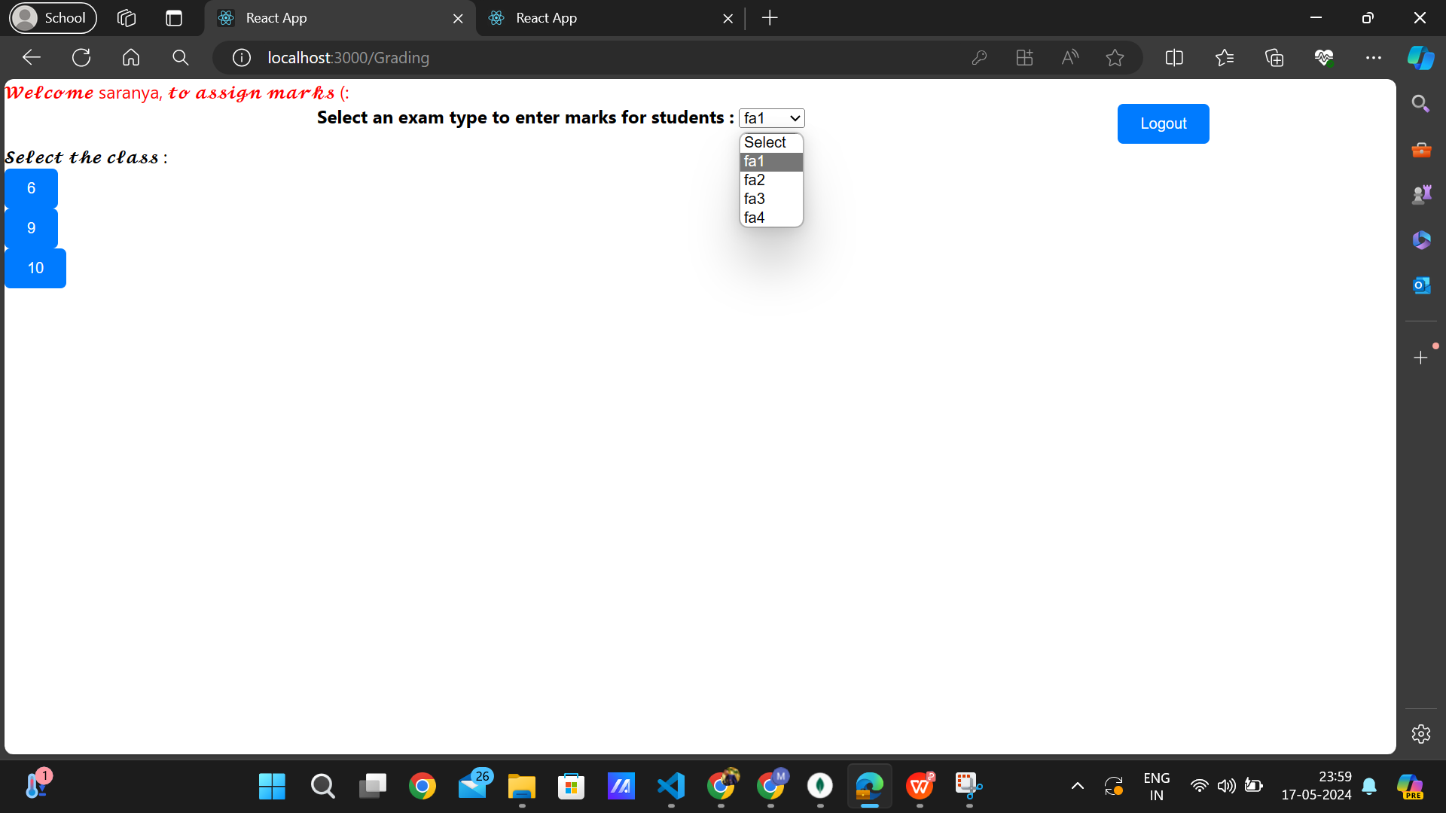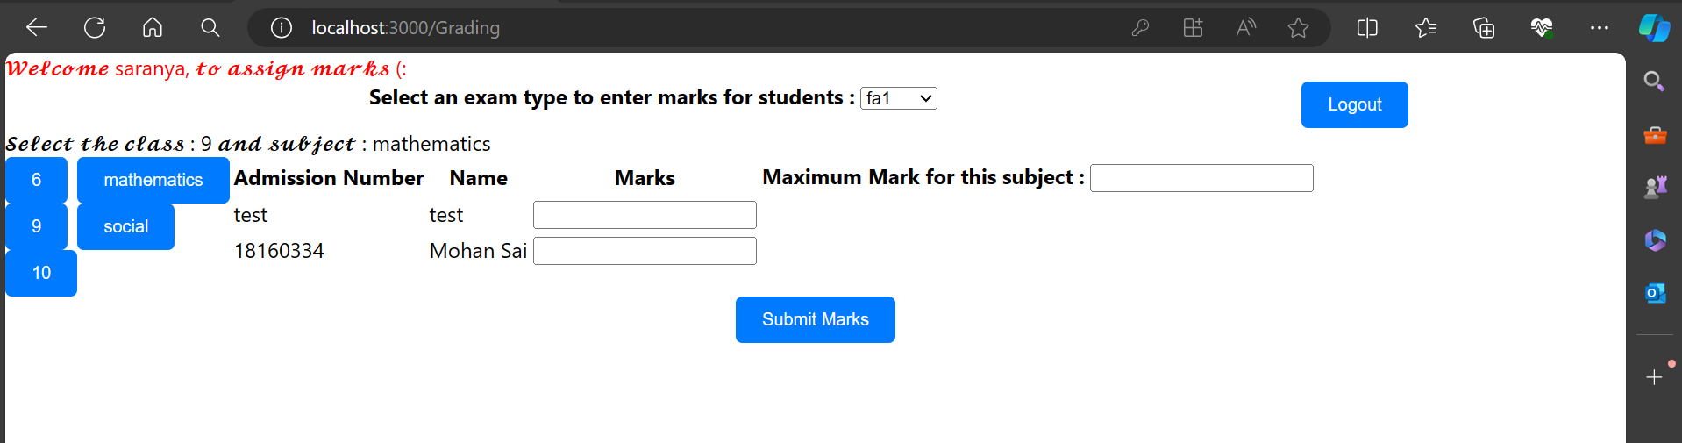

It displays all the classes of which a respected teacher could go and respective subjects and the lost of student in the selected class.

After clicking the submit button, it sends the information to the database.

-------------------------------------------------------------------------------------------------------------

5) **About School info :**



---------------------------------------------THE END ----------------------------------------------------